Testing Attendance Scan

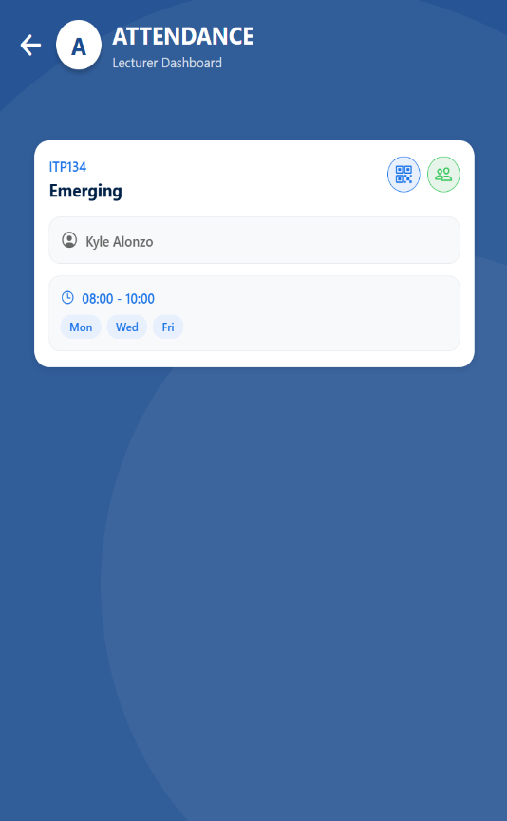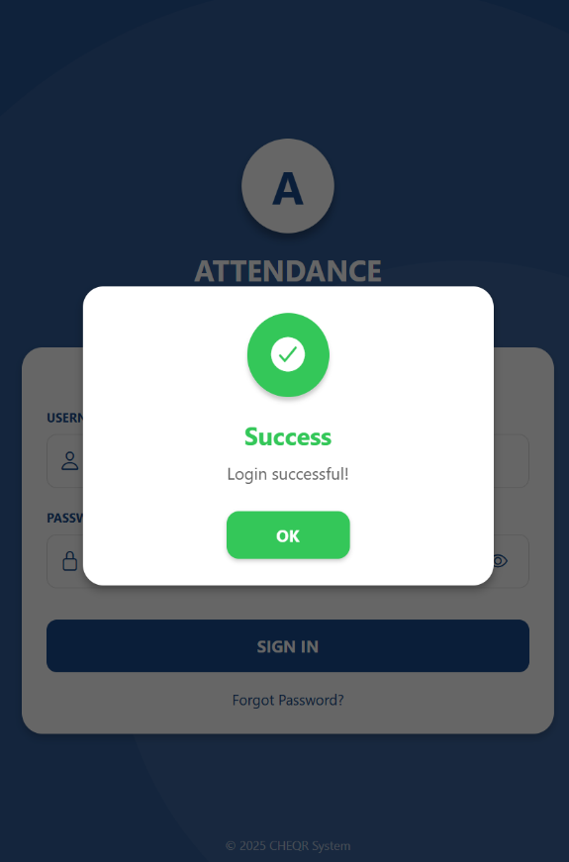Step 1: The Lecture log in into system.

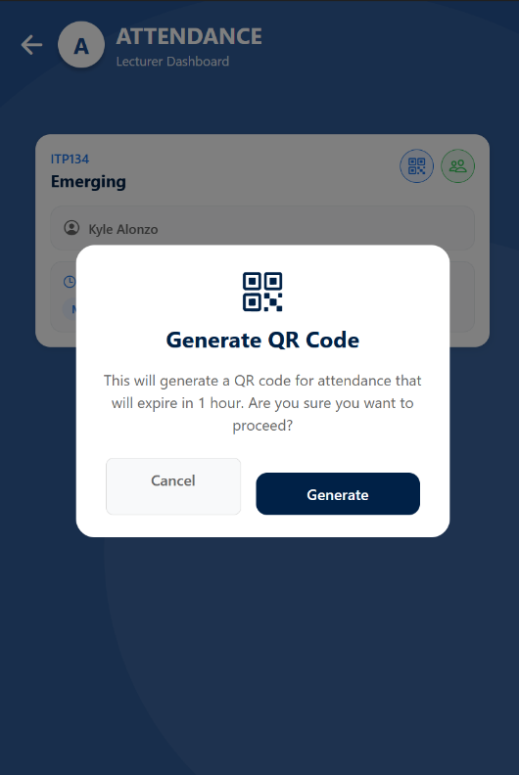  
Step 2: Step 2: Lecturer Generate the QR Code from the class they handle.

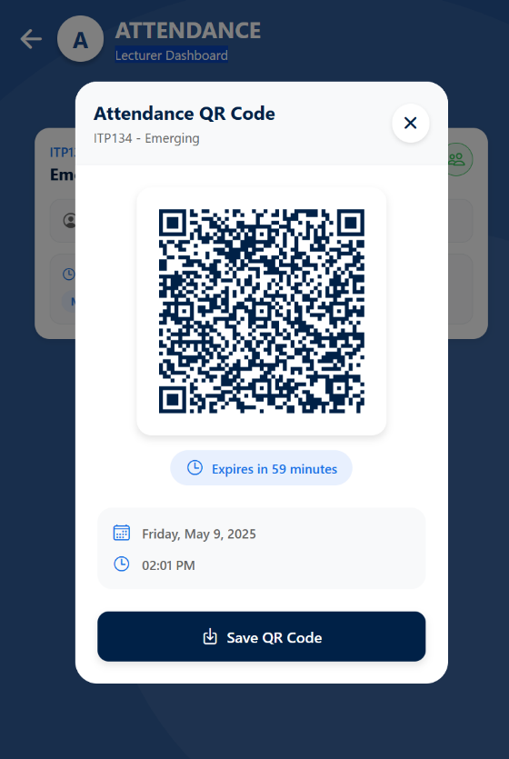Step 3: Lecturer show the QR Code generated code to the student so that the student can scan it.

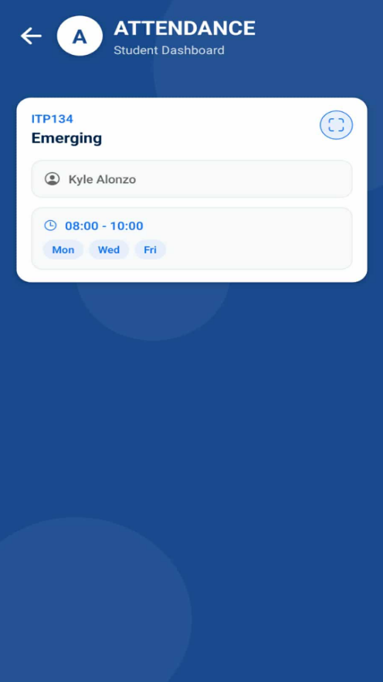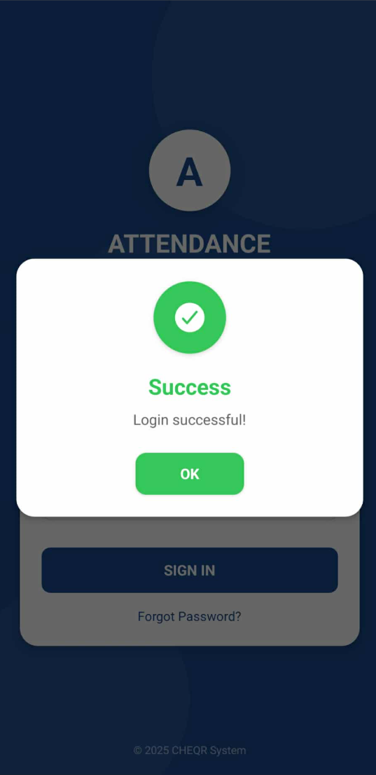Step 4: Student will log in to the system

Step 5: Student will open the class where they enroll to open the camera icon.

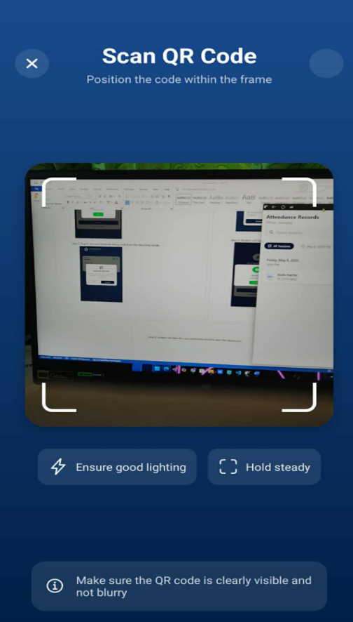

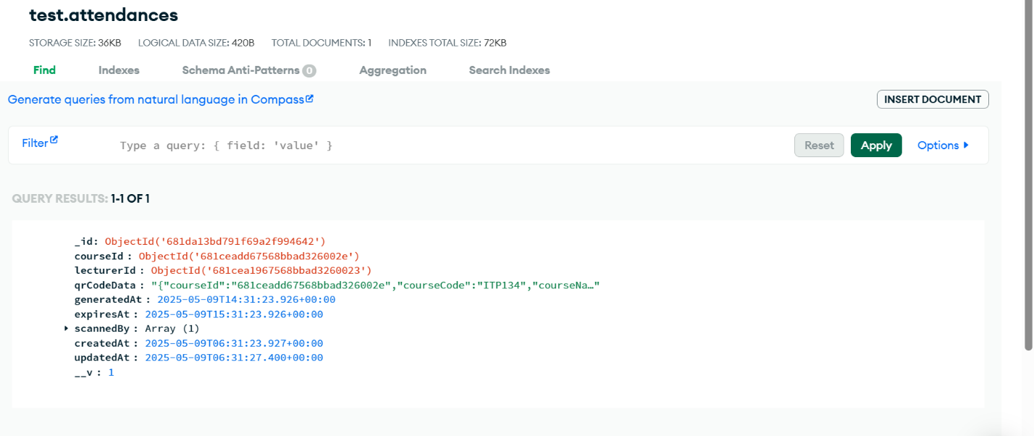Step 6 Tester Open workbench view on to the attendance

step 7: screen shot the table attendance state noting the existing attendance state

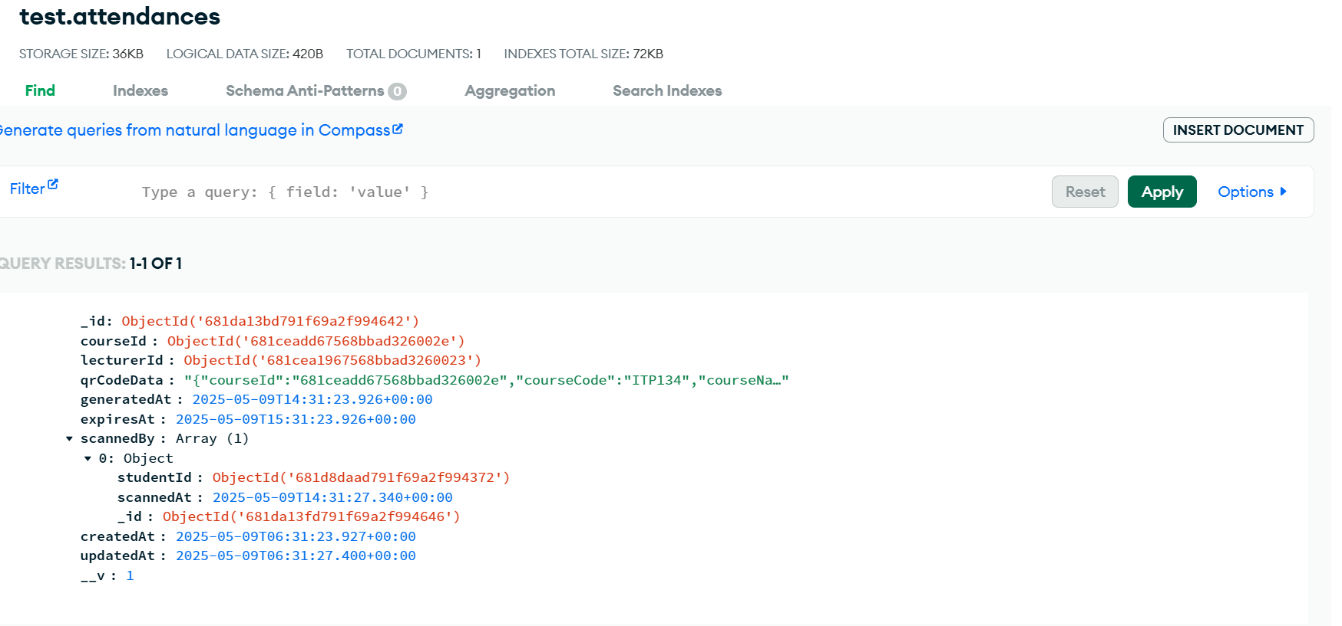

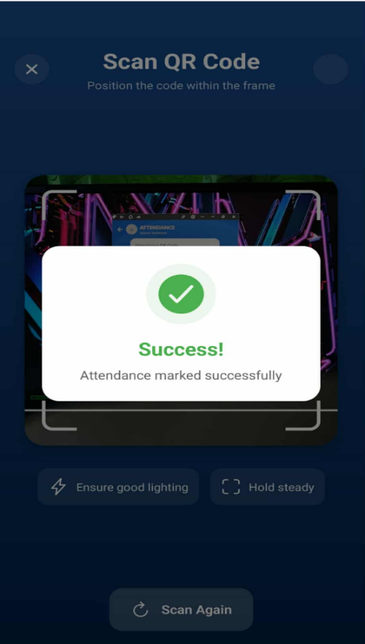Step 8: Student now scan success

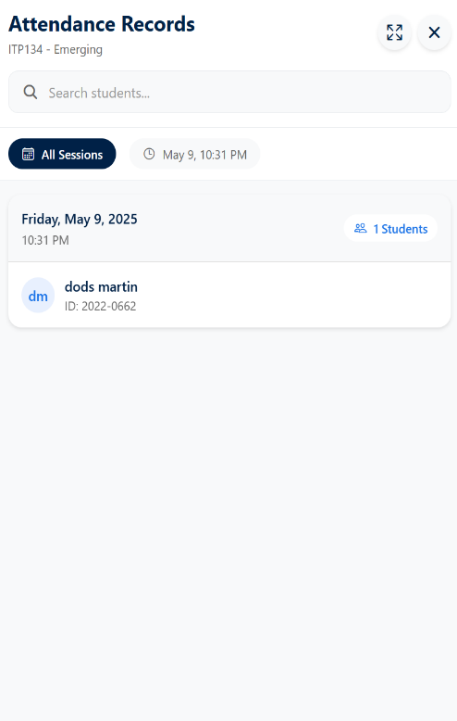step 8 EXPECT to see as new row reflecting the new attendance: only the student that scan the QR Code will listed in the attendance screen.